1. **Deploy Your flask backend and express frontend in amazon single ec2 instance.**

1.Launch EC2 Instance

EC2 → Launch Instance → course

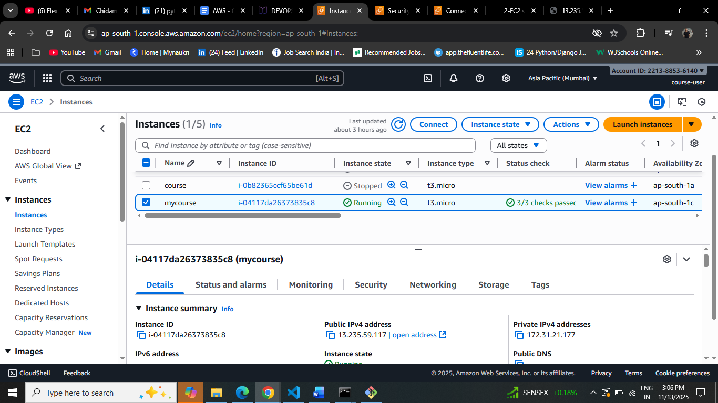

1. Connect via SSH

ssh -i ~/.ssh/key_pair.pem [ubuntu@ec2-13-235-59-117.ap-south-](mailto:ubuntu@ec2-13-235-59-117.ap-south-)1.compute.amazonaws.com

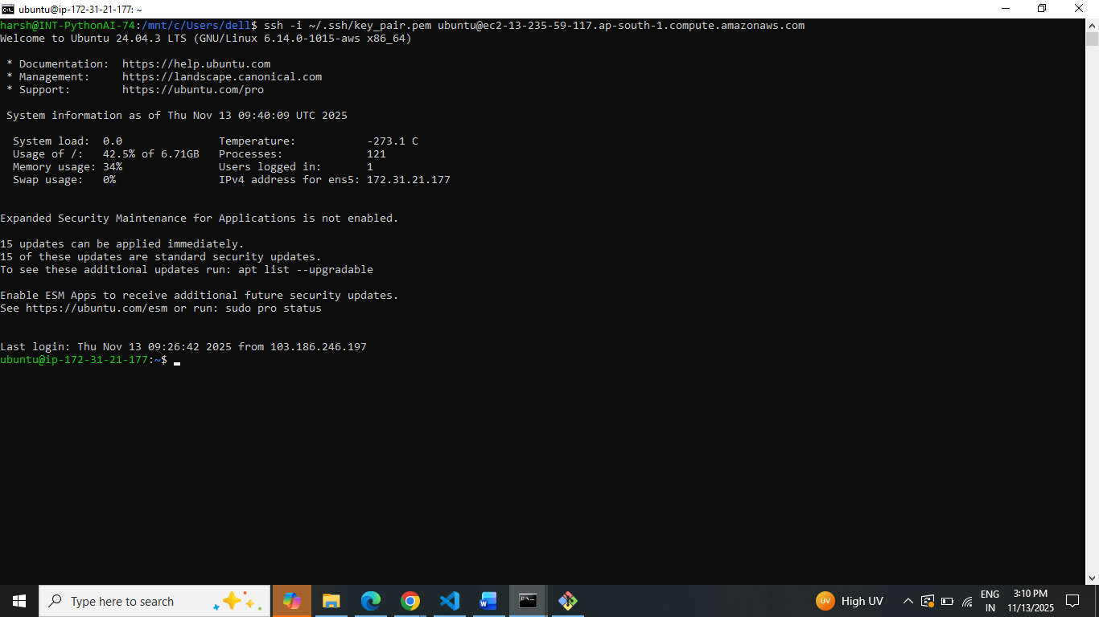

3.Flask Backend

Run Flask server:

Python3 app.py

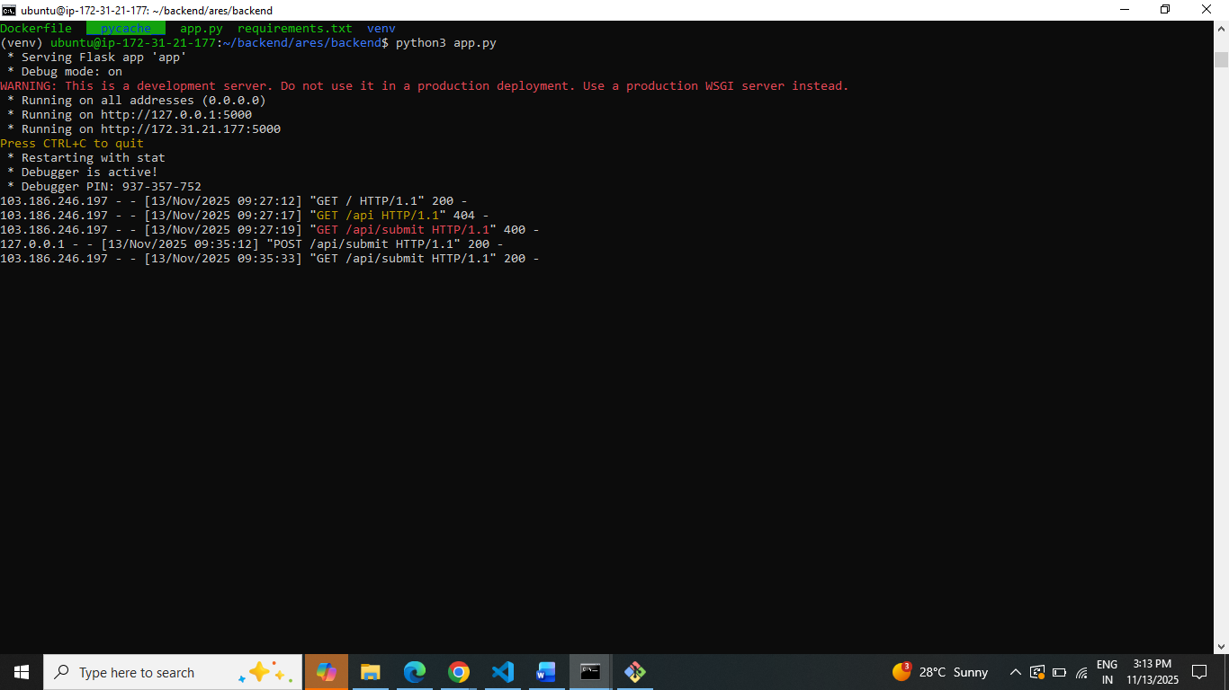

4.Express Frontend

Run Node.js server

npm start

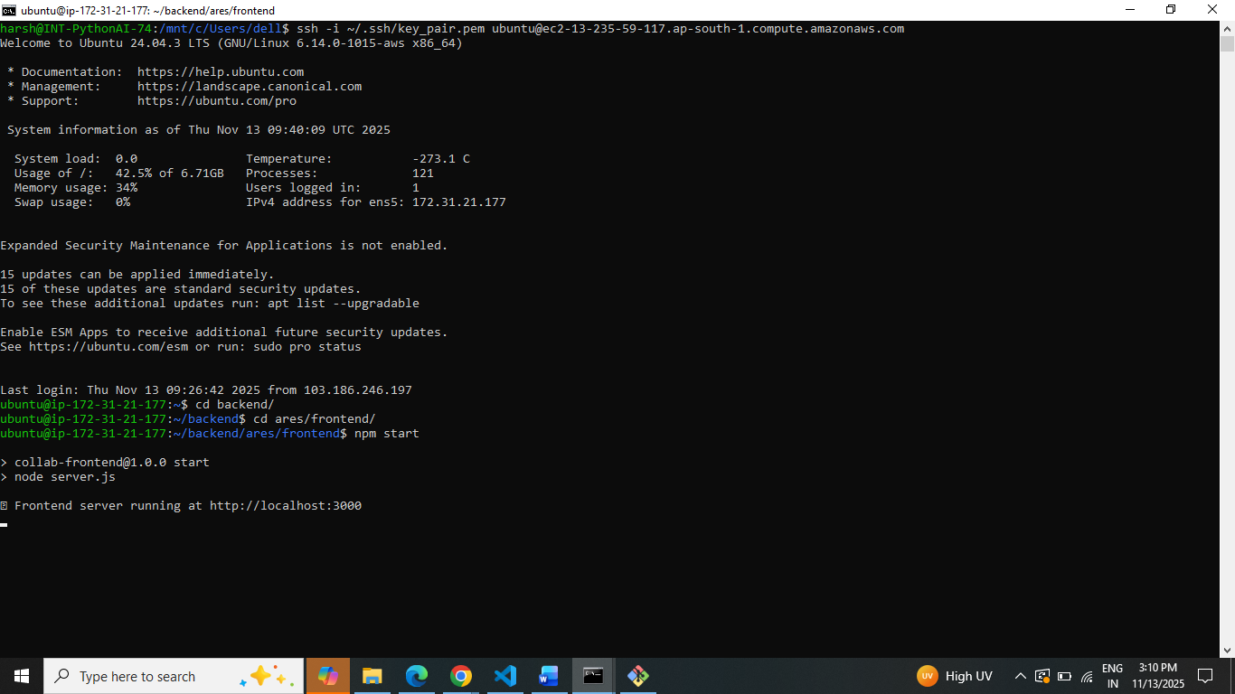

5. Access Your App

Express: http://<ec2-public-ip>:3000

http://13.235.59.117:3000

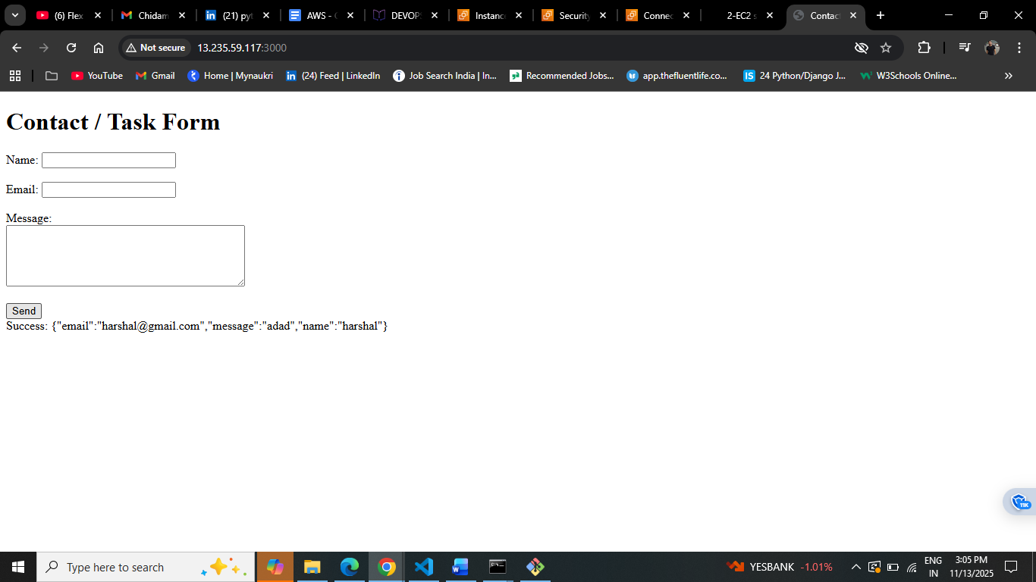

Flask: http://<ec2-public-ip>:5000

http://13.235.59.117:5000/api/submit

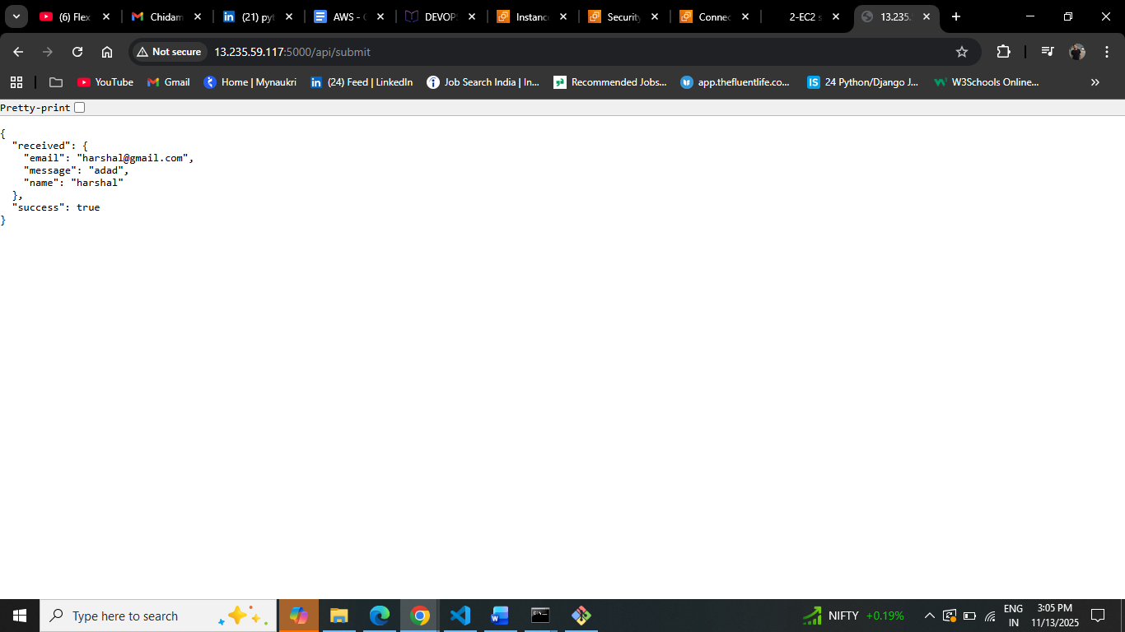

1. **Deploy Your flask backend and express frontend in separate ec2 instances.**

**Frontend**

1.Launch EC2 Instance

EC2 → Launch Instance → Frontend

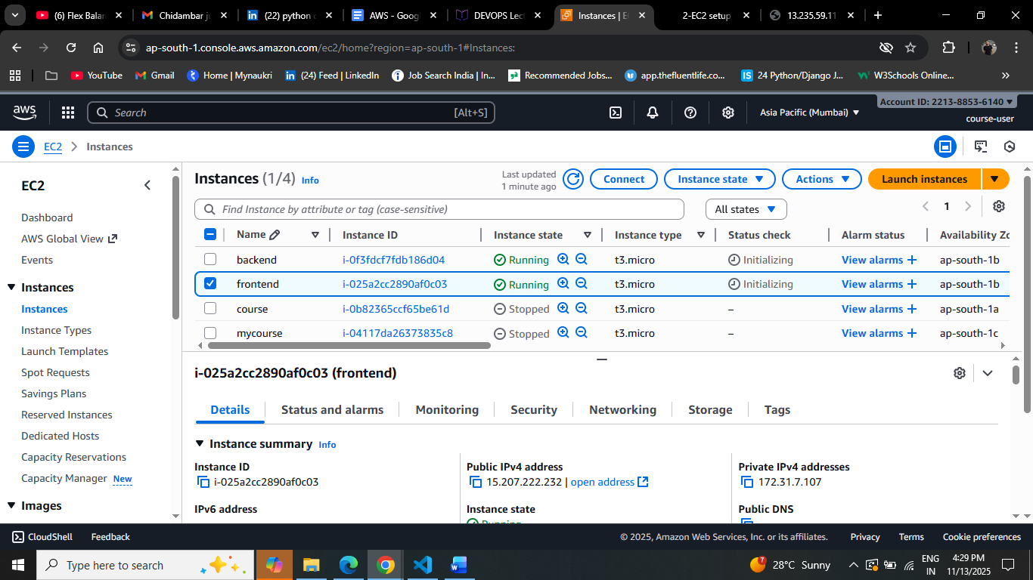

2. Connect via SSH

ssh -I ~/.ssh/key_pair.pem [ubuntu@ec2-15-207-222-232.ap-south-1.compute.amazonaws.com](mailto:ubuntu@ec2-15-207-222-232.ap-south-1.compute.amazonaws.com)

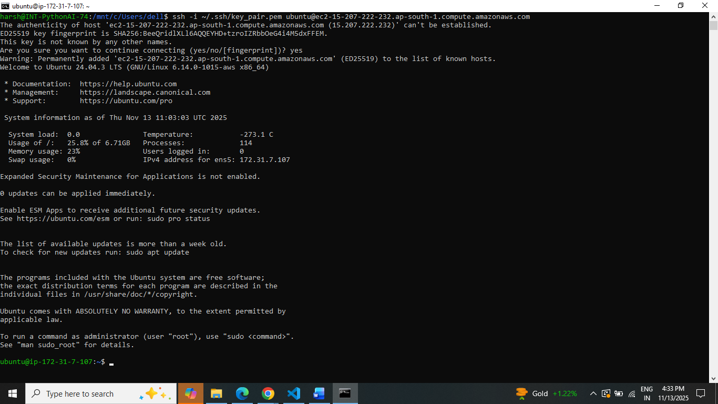

3. Security Permission PORT

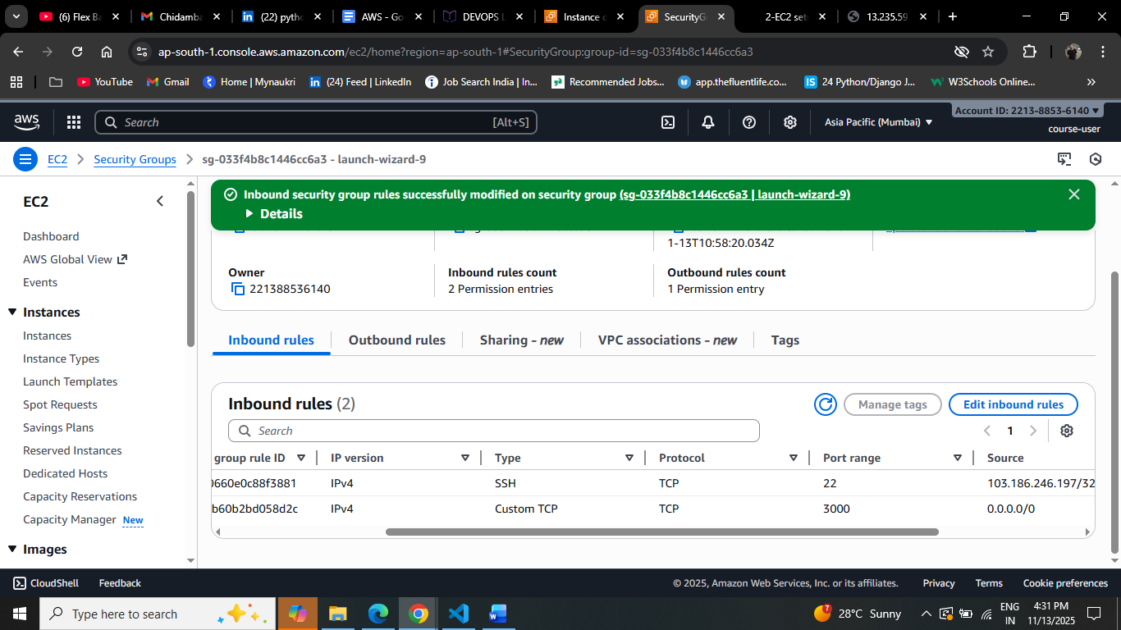

4.Copy File From Local

scp -i ~/.ssh/key_pair.pem -r /mnt/c/Users/dell/collab_from_project/ares/frontend [ubuntu@13.234.66.86:~/frontend](mailto:ubuntu@13.234.66.86:~/frontend)

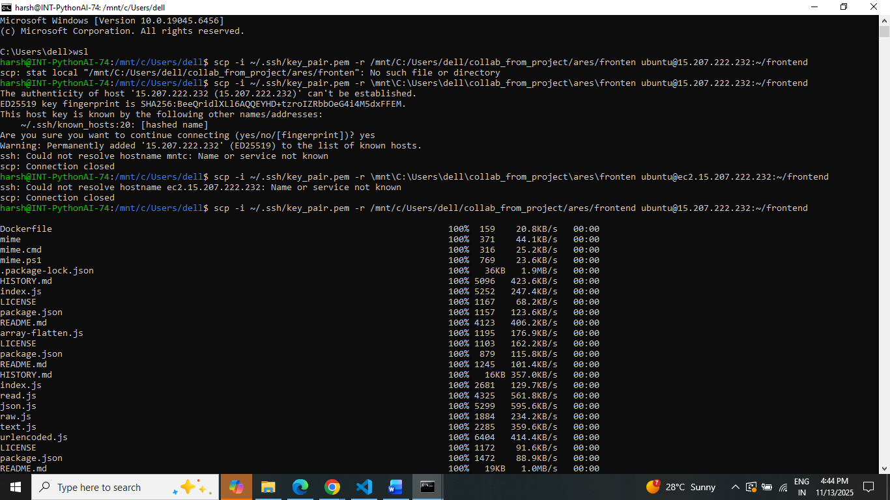

5.Start Server

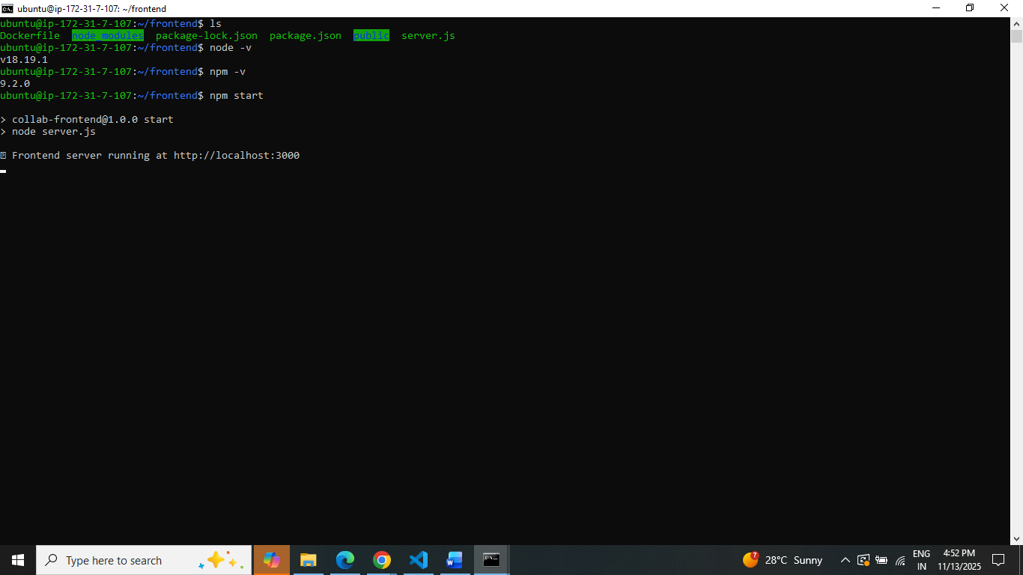

6. Access Your App

Express: http://<ec2-public-ip>:3000

<http://15.207.222.232:3000>

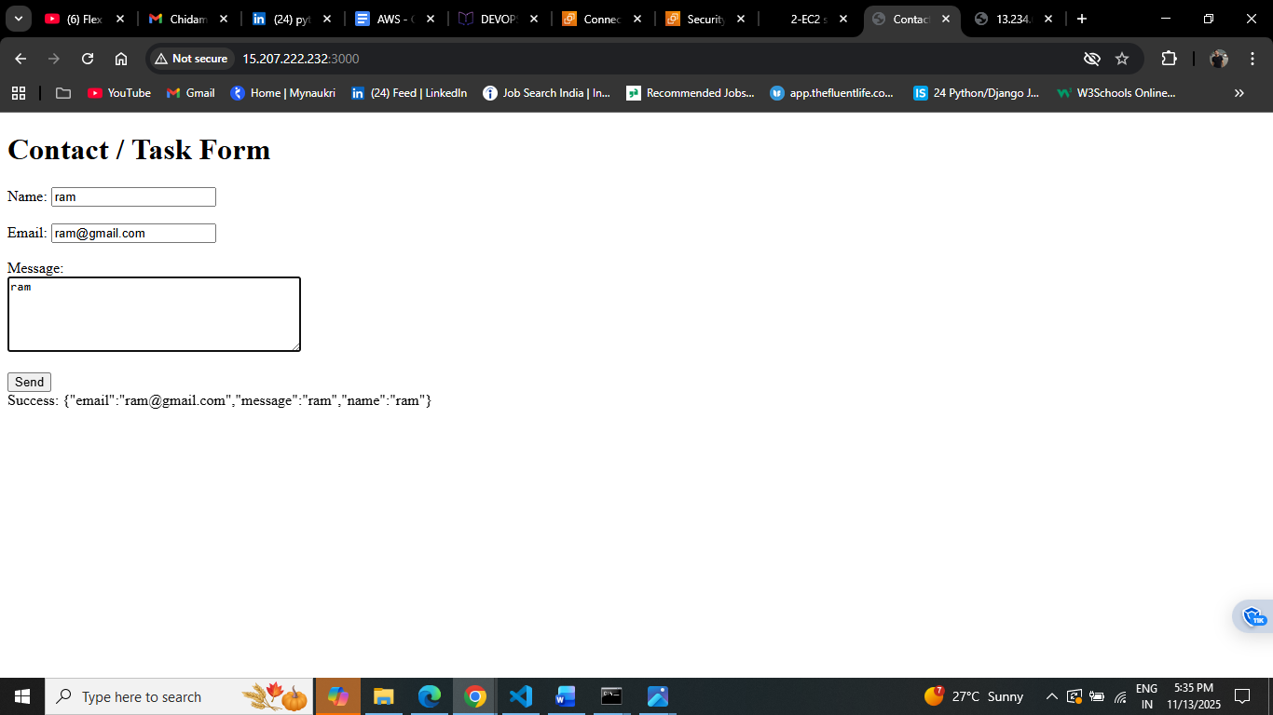

**Backend**

1.Launch EC2 Instance

EC2 → Launch Instance → Backend

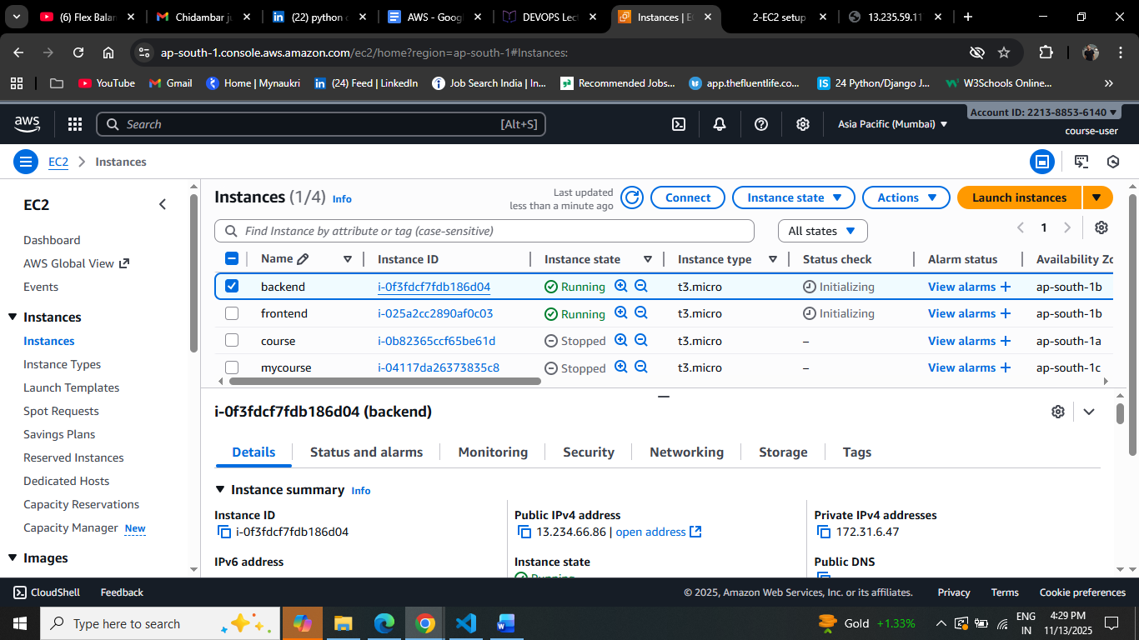

2.Connect via SSH

ssh -i ~/.ssh/key_pair.pem [ubuntu@ec2-13-234-66-86.ap-south-1.compute.amazonaws.com](mailto:ubuntu@ec2-13-234-66-86.ap-south-1.compute.amazonaws.com)

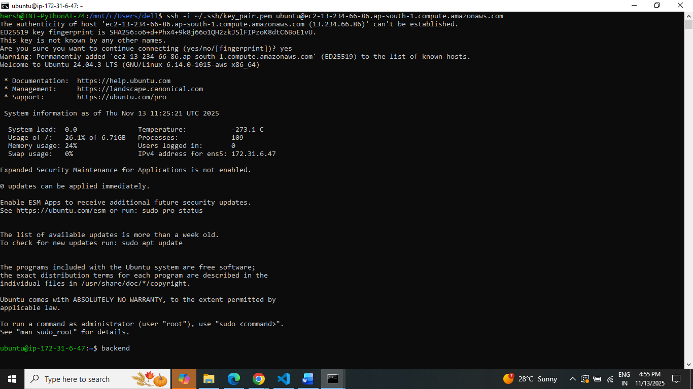

3.Security Permission PORT

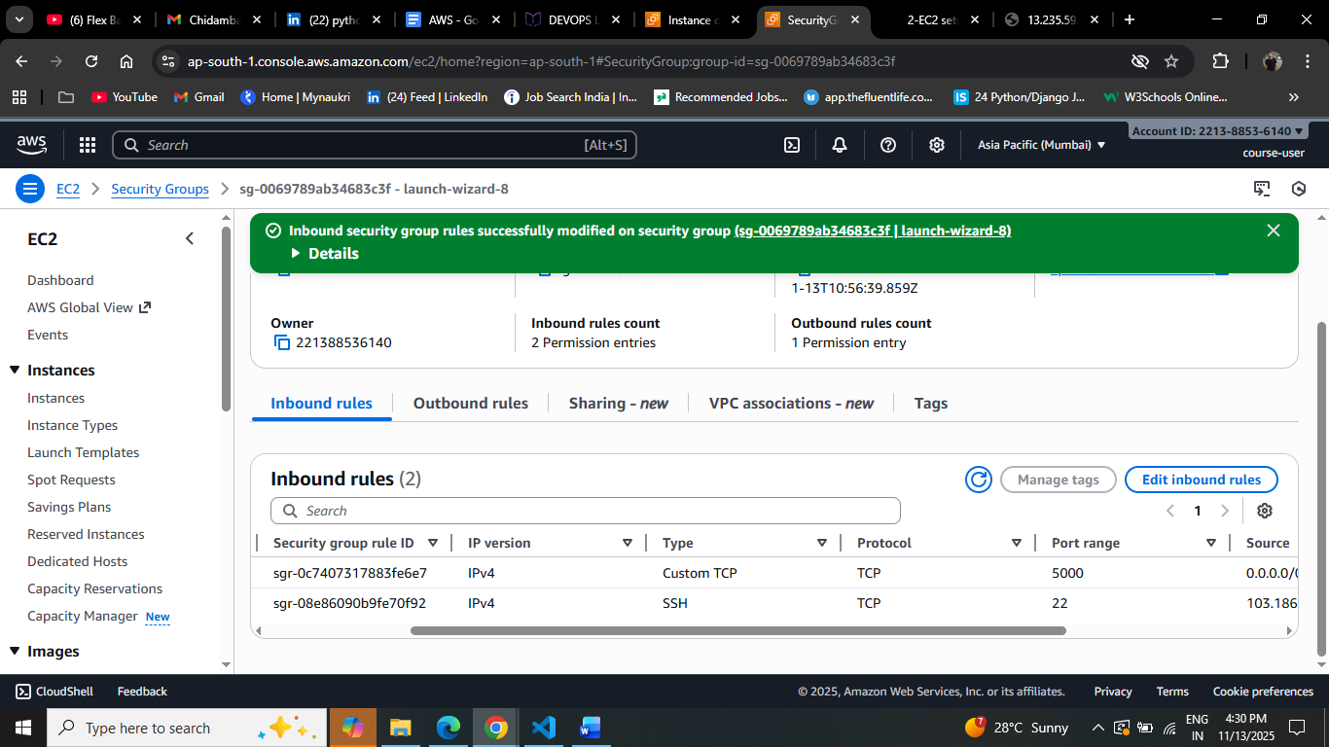

4.Copy File From Local

scp -i ~/.ssh/key_pair.pem -r /mnt/c/Users/dell/collab_from_project/ares/backend [ubuntu@13.234.66.86:~/backend](mailto:ubuntu@13.234.66.86:~/backend)

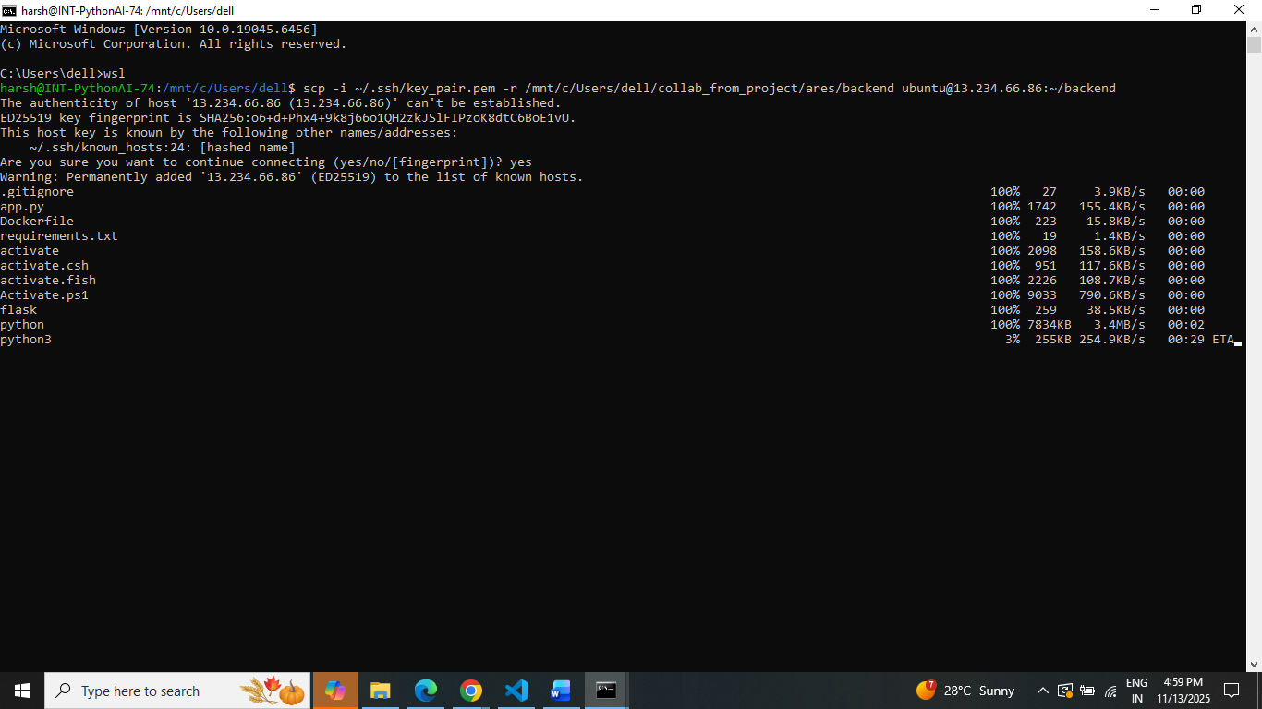

5.Start Server

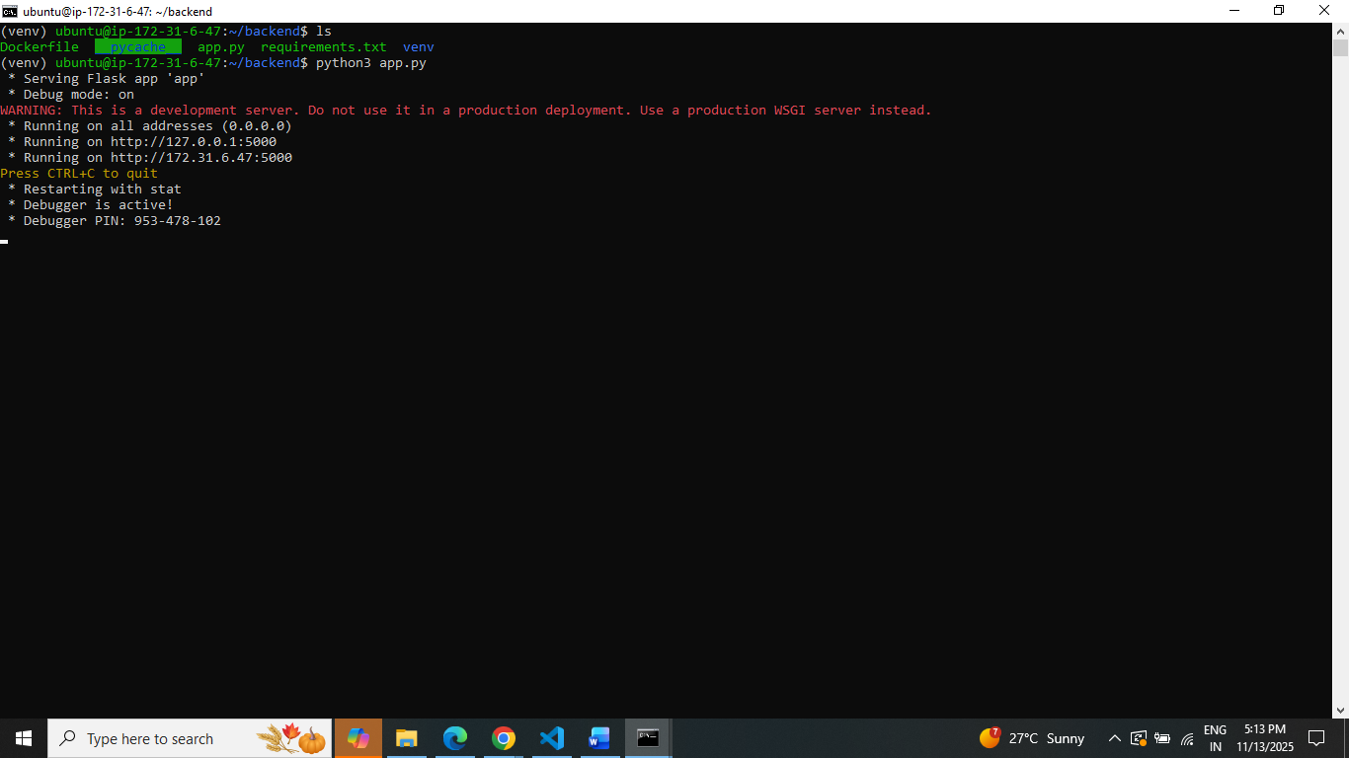

6.Access Your App

Express: http://<ec2-public-ip>:5000

<http://13.234.66.86:5000/api/submit>

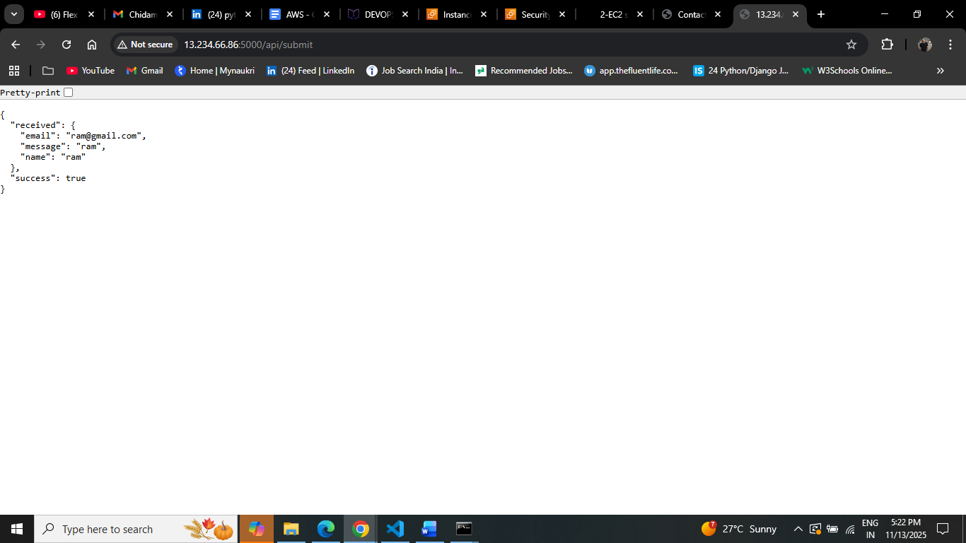

1. **Deploy Your flask backend and express frontend Docker Container using aws ecr, ecs and vpc services**

**ECR**1.Create Repository

Backend and Frontend

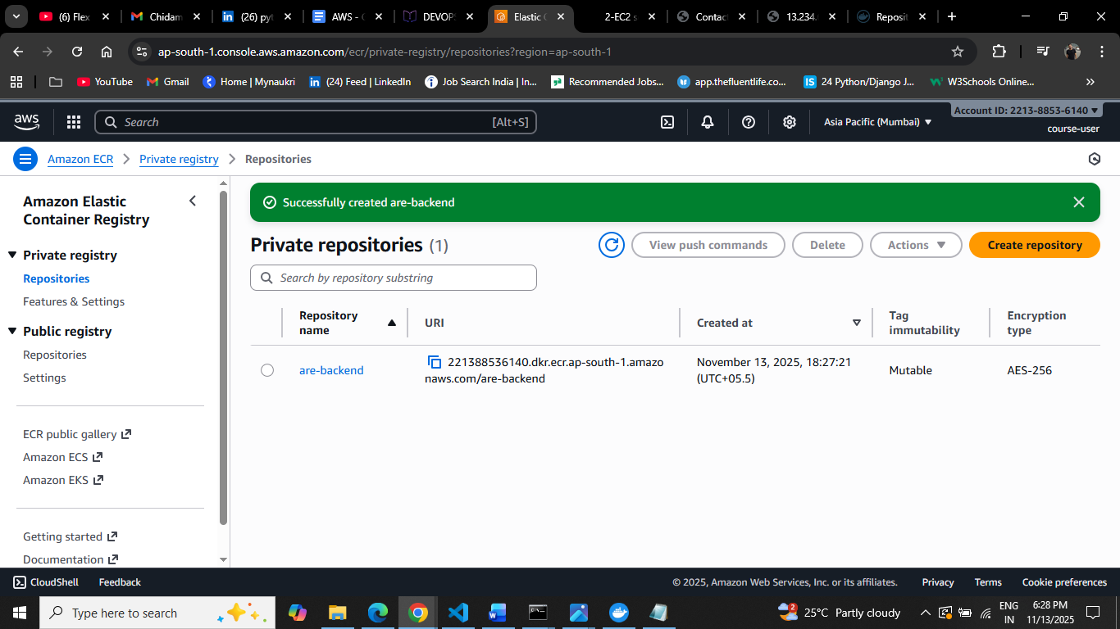

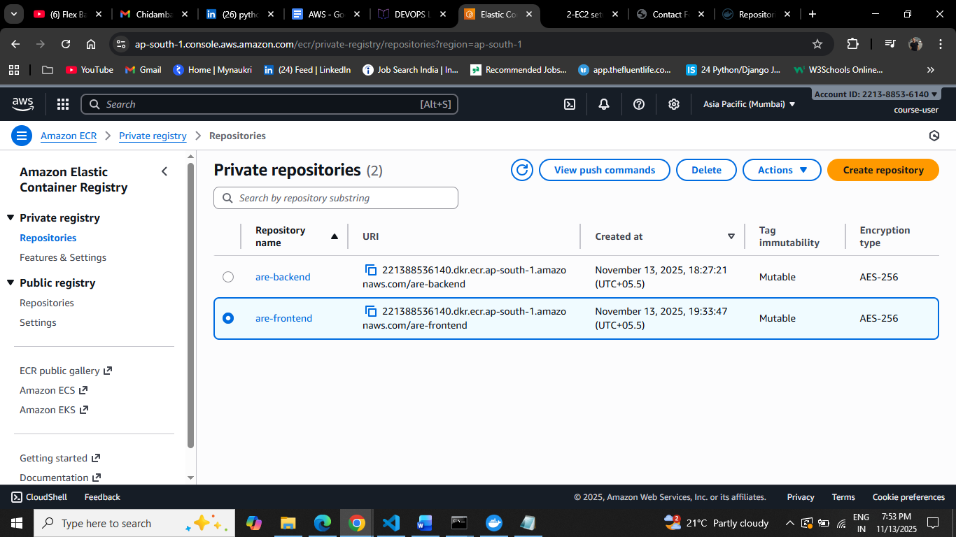

2.Follow the steps of Push

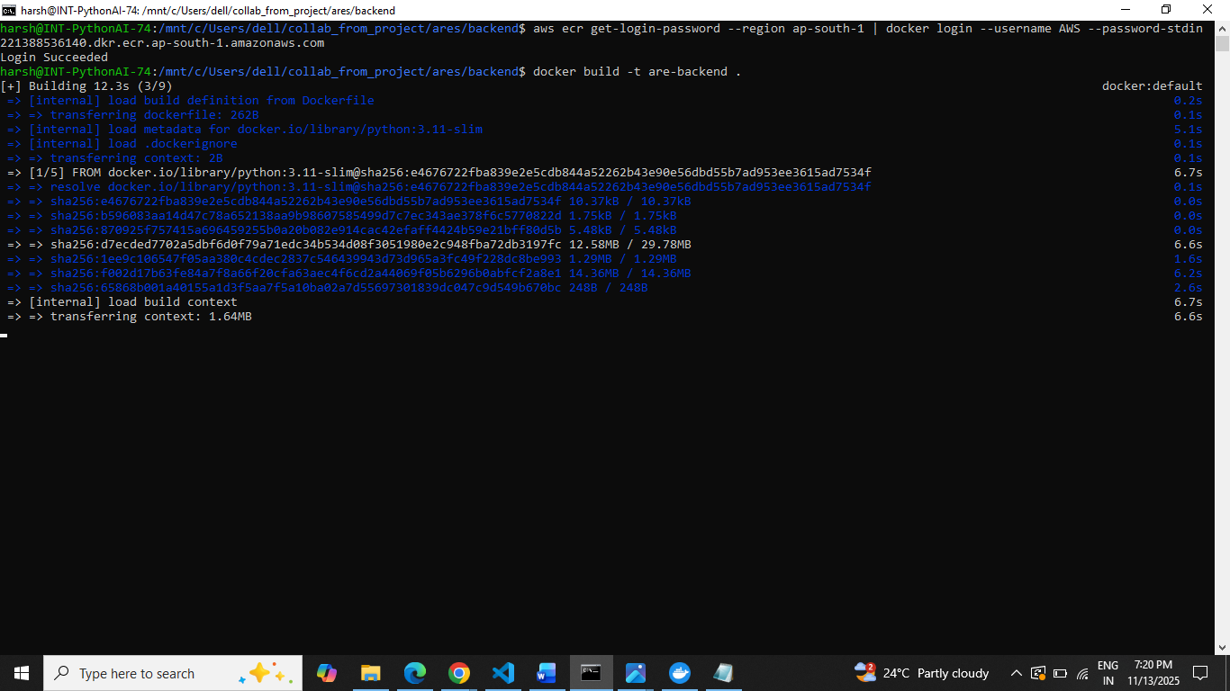

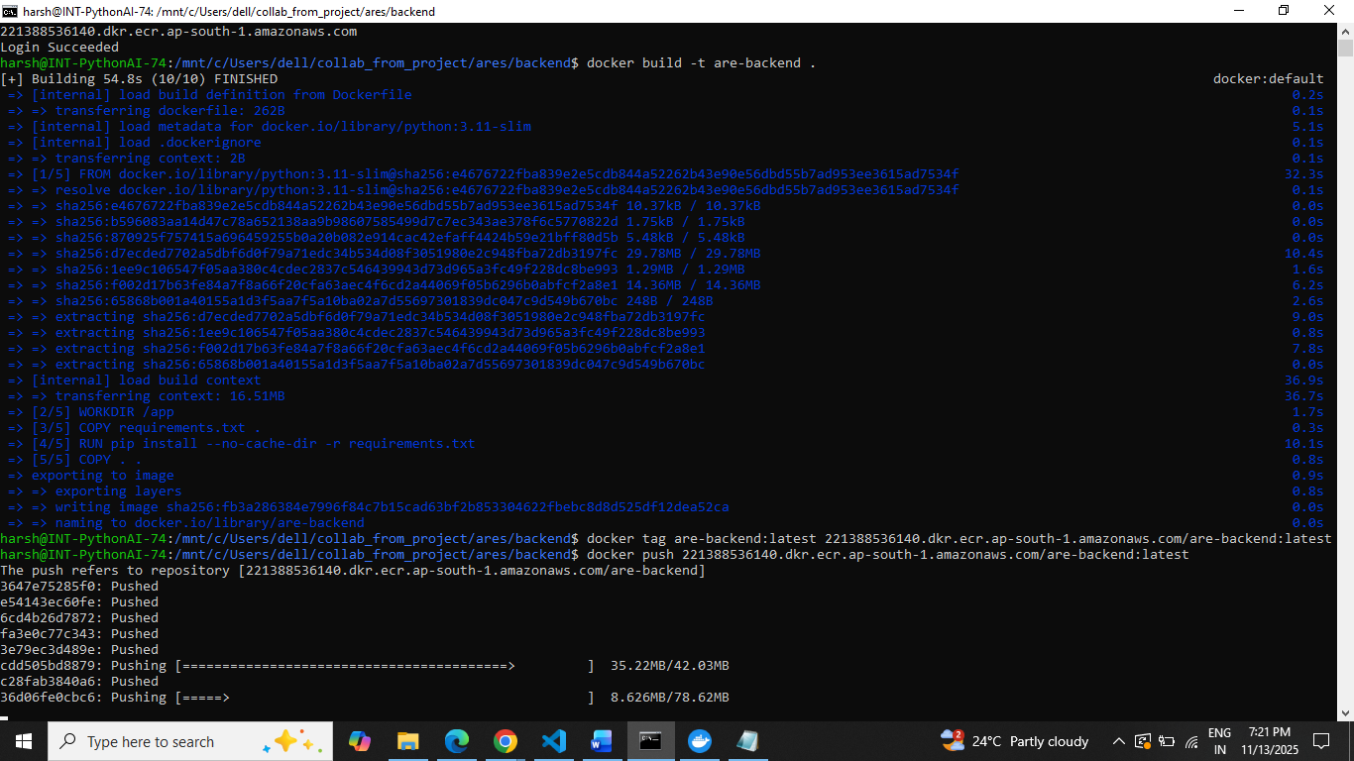

3.Backend and Frontend Image

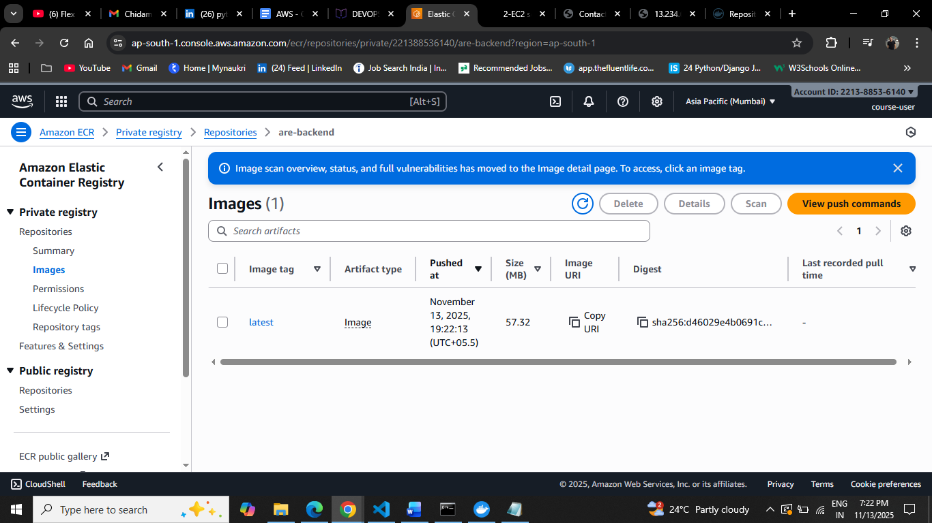

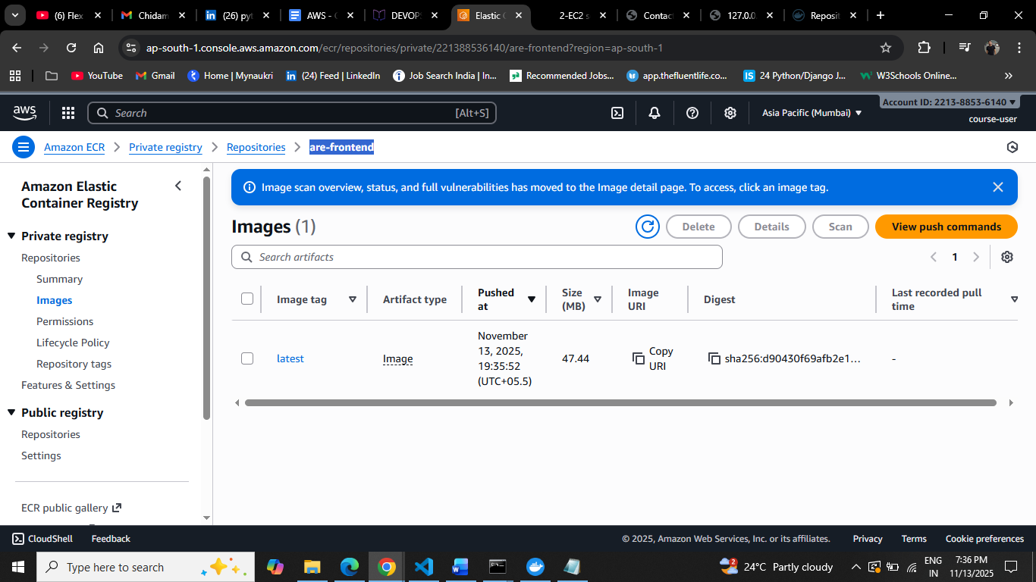

4.Run Backend and Frontend

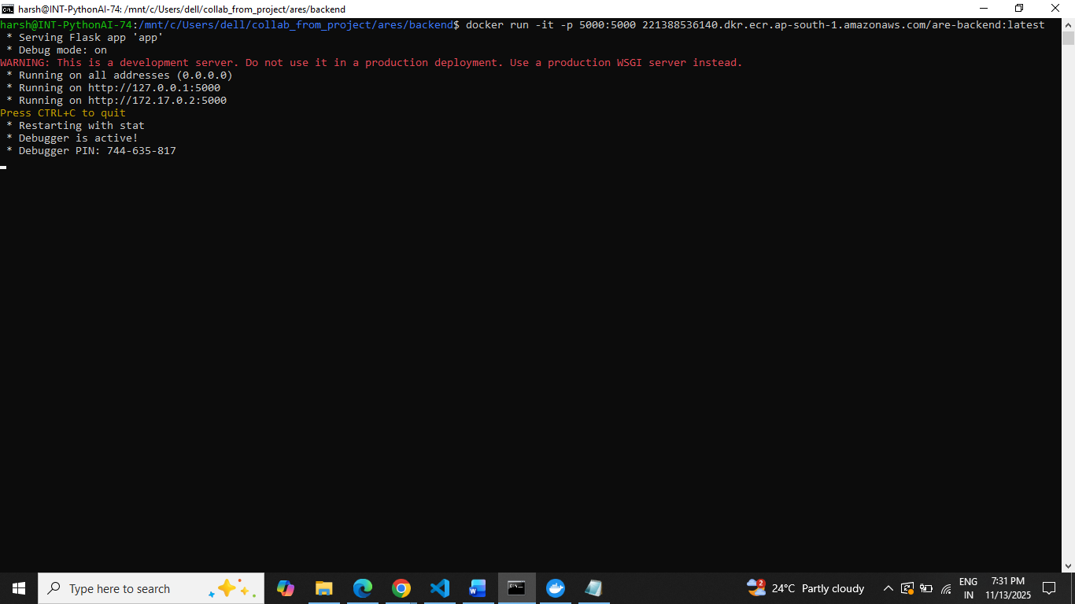

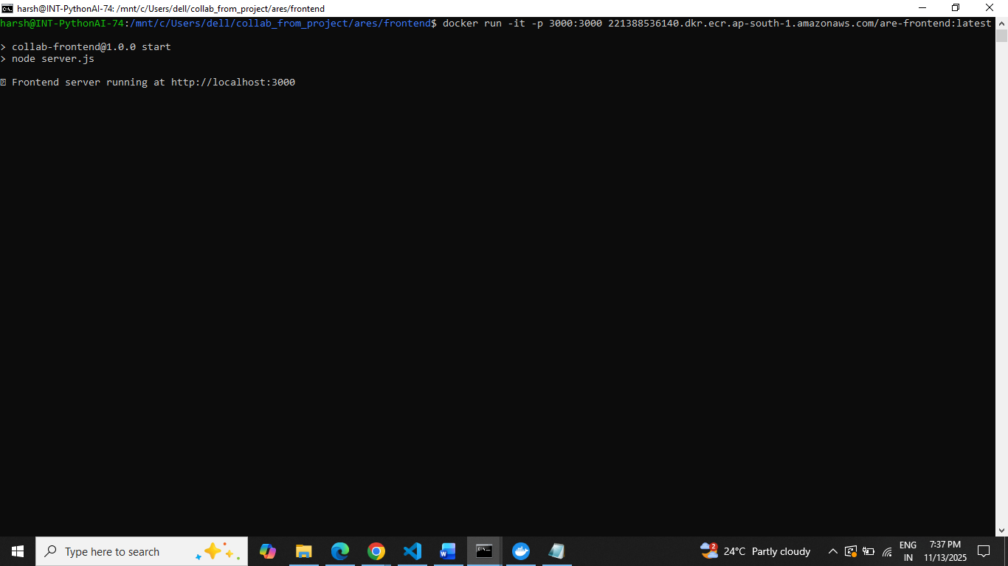

5.API Calling Backend and Frontend

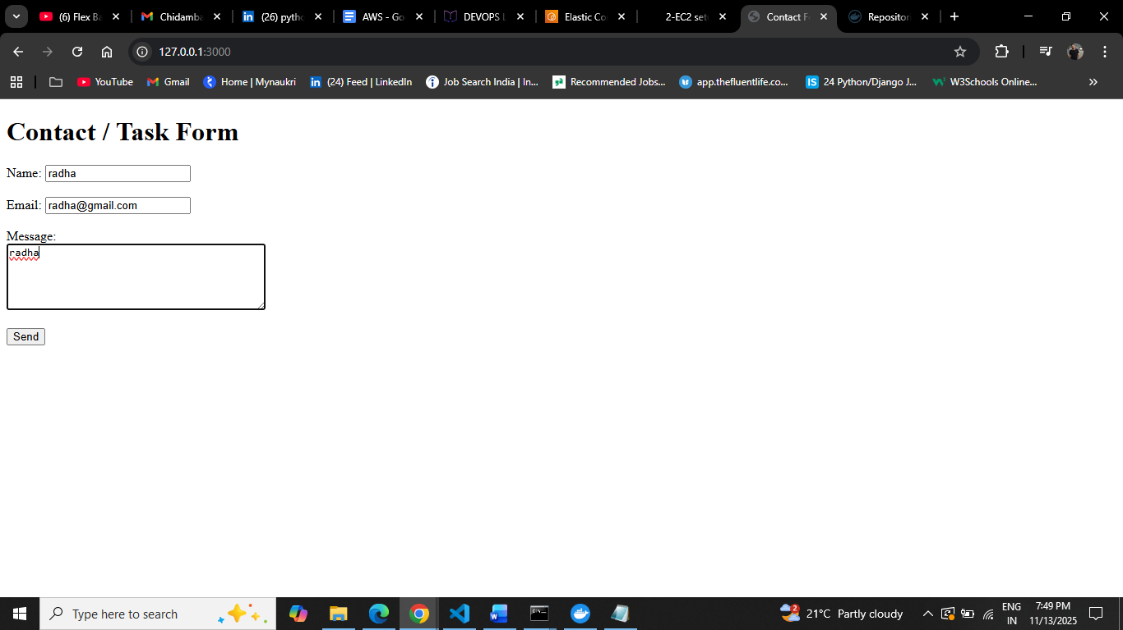

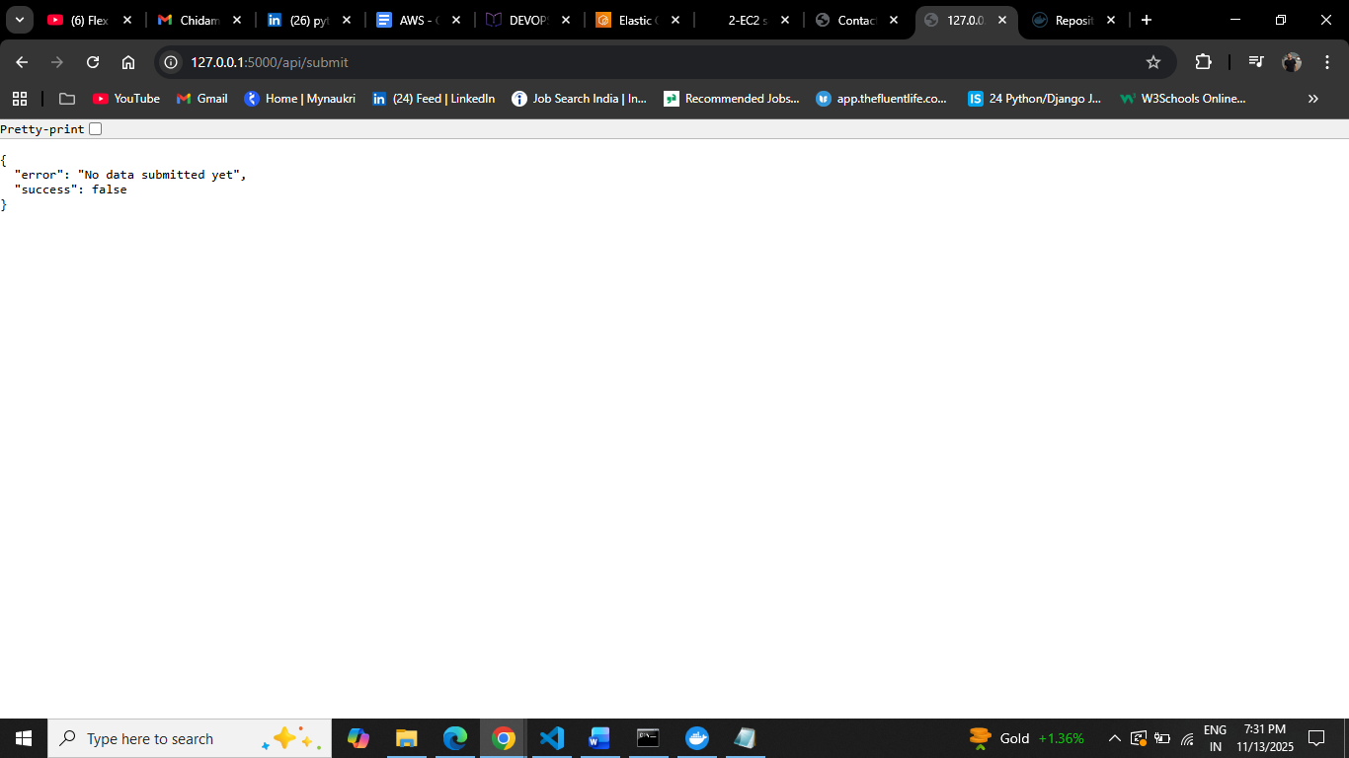

**ECS**

1.Create Cluster

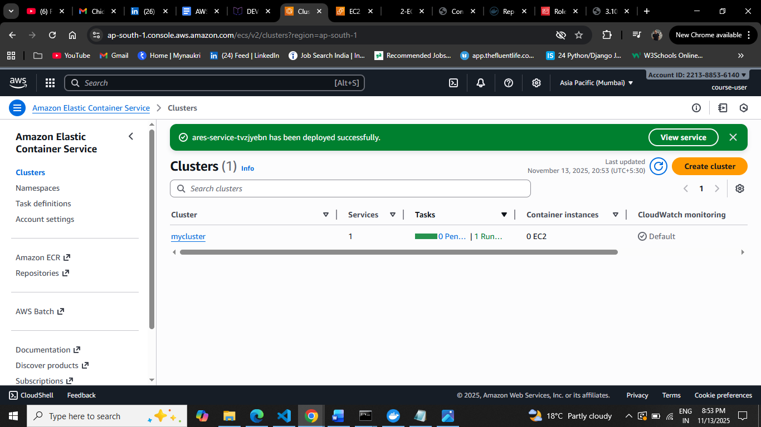

2.Create Task

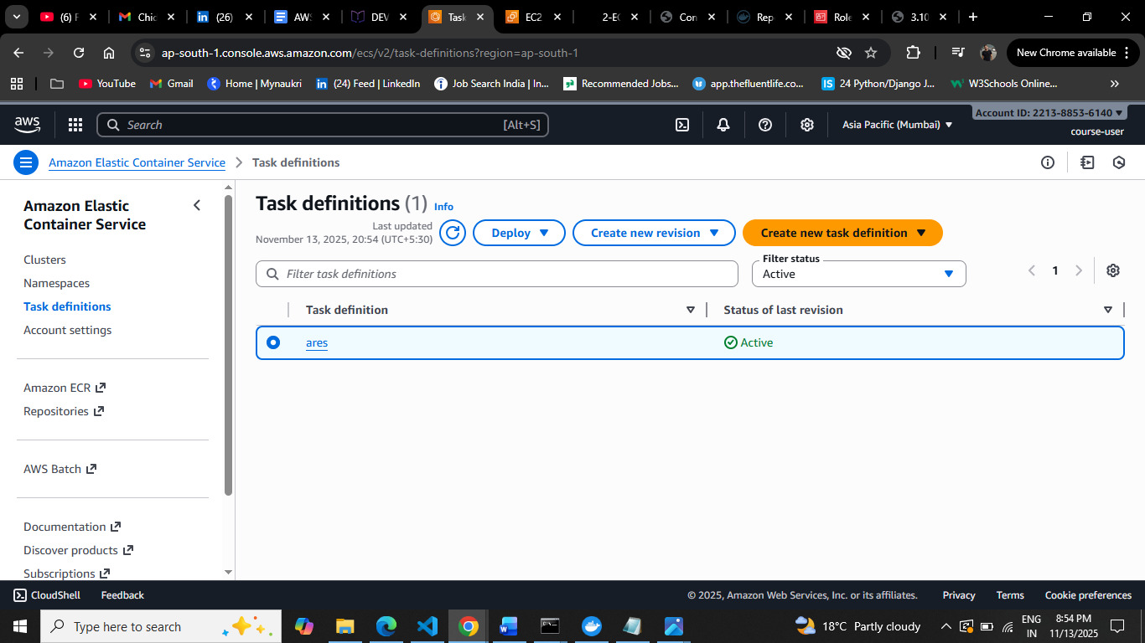

3.Create Role

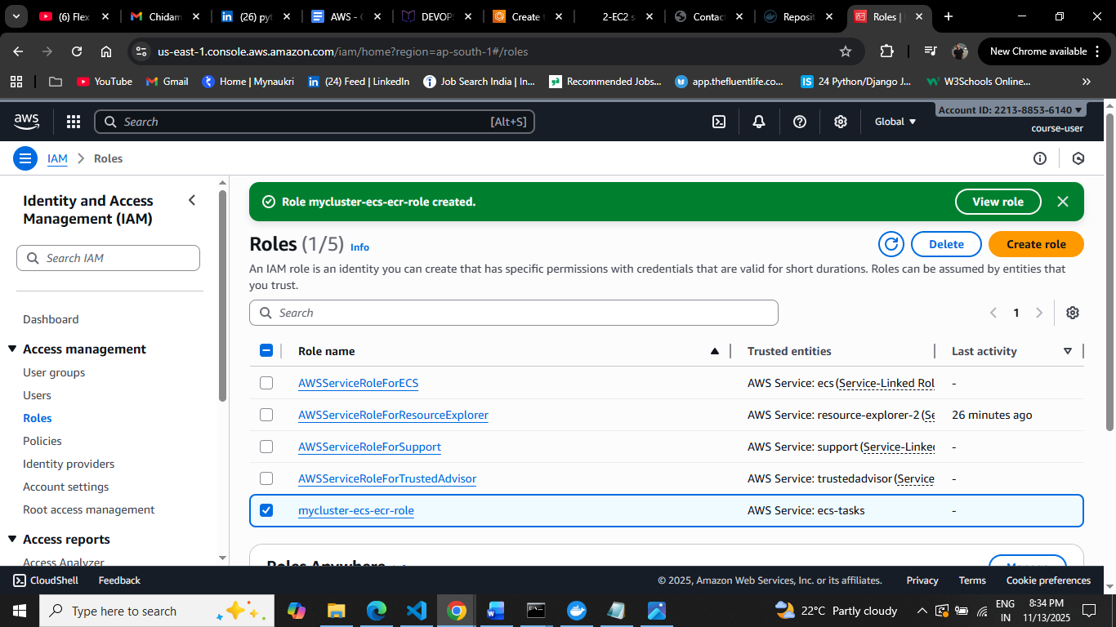

4.Create Service

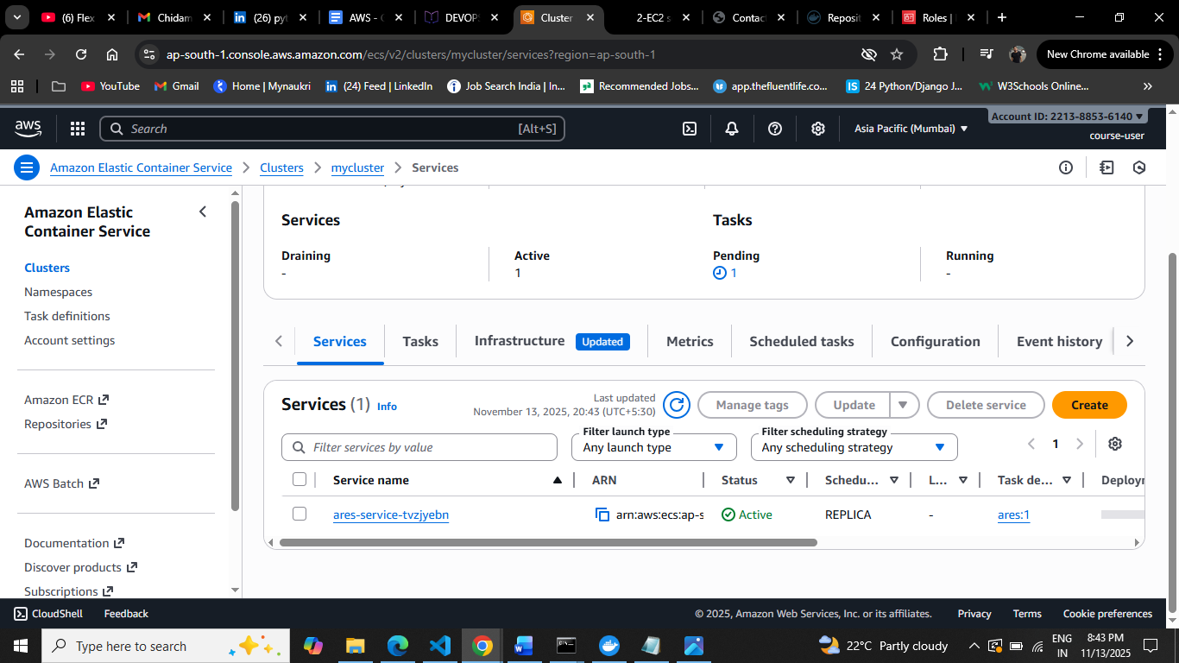

5.Permission Port

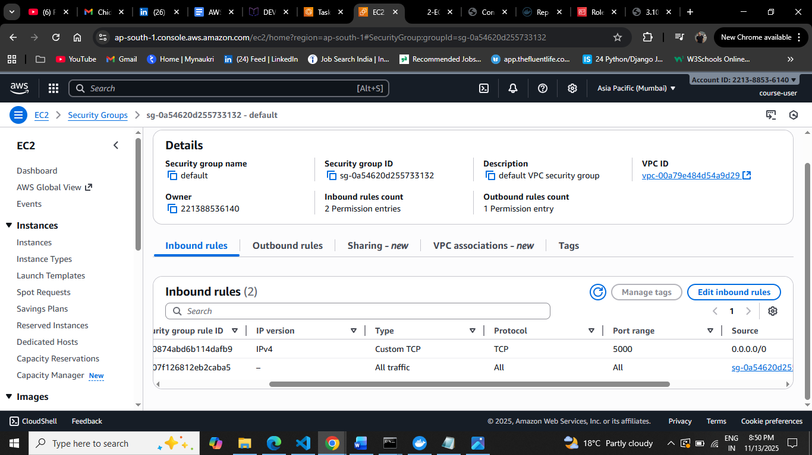

6.Public IP ID

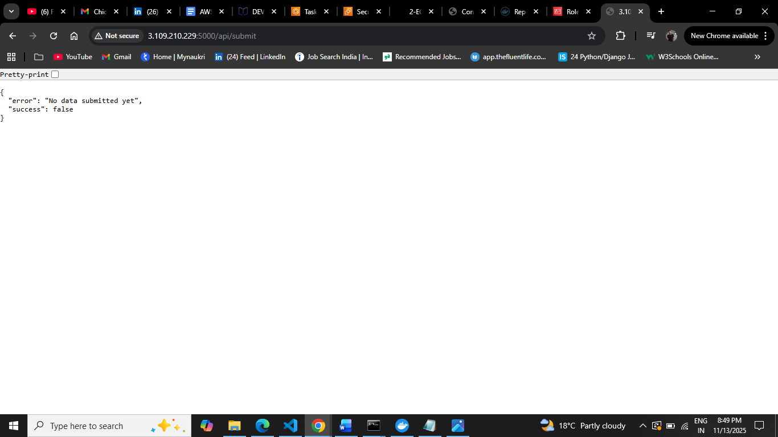

**VPC**

1. VPC

